Name: Ghazal Fatima
Roll no: 31
Program: Computer Science
Section: A
Submitted To: Sir Asad Majeed
Date: 11-10-2026

TASK 1:
Run the following program and check the output.
#include <iostream>
using namespace std;
int main()
{
cout << "hello world" << endl; // prints hello world and endl means end the line
system("pause"); // to stop output window
return 0;
}
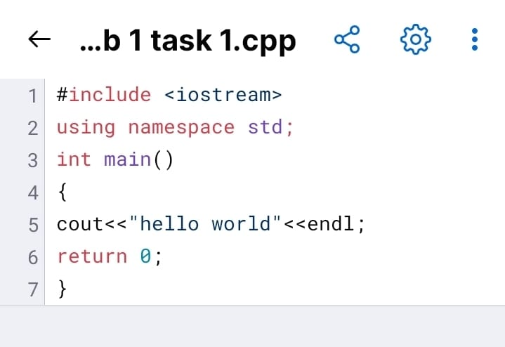
TASK 2:
Write a C++ program to print the following lines:
You are 10 years old.
You are too young to play the game.
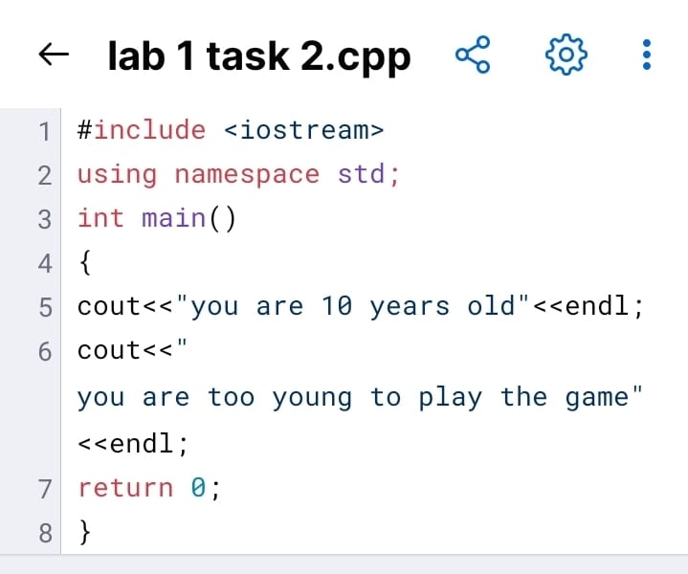
TASK 3:
Write five C++ statements to print the asterisk pattern as shown below.
*
**
***
****
*****
